Assignment 2:
Badshah Jan (2280175)
BSSE-7B
LAB 2a:
TASK 1:
Subscription Information Review:
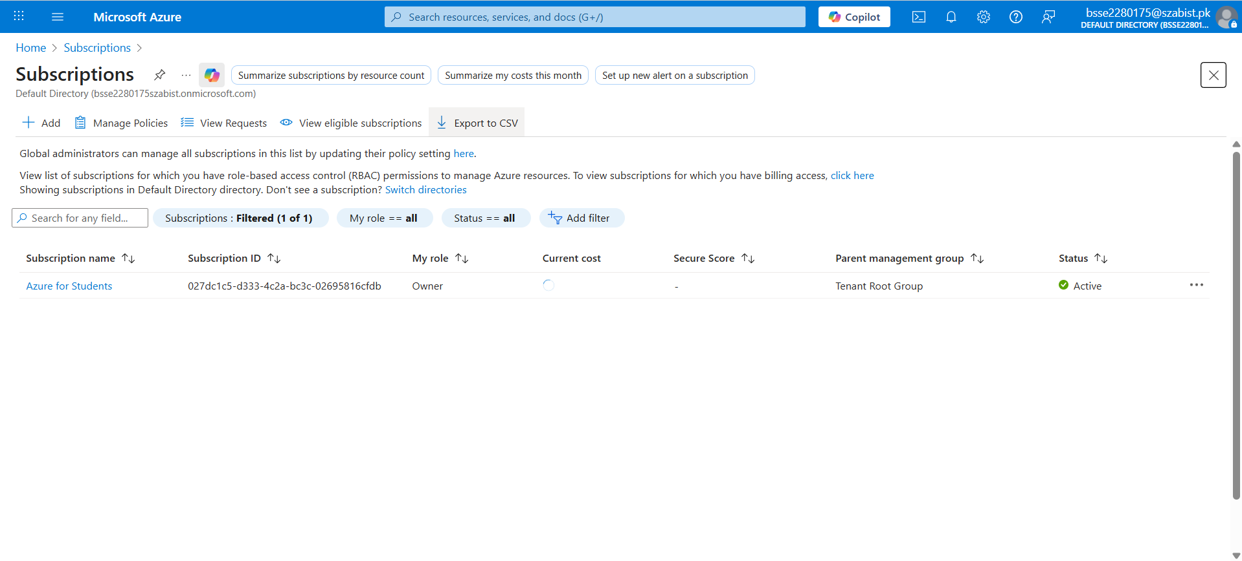
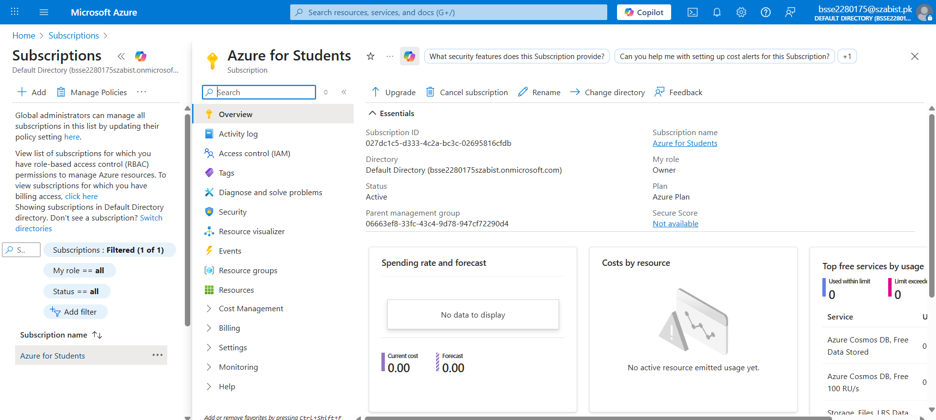

TASK 2:
RBAC – Role Assignments:
